# Introduction

With adaptive gaming joysticks that are compatible with both PC and XAC being difficult to source globally, MMC aims to provide a cost-effective, open source customizable joysticks using easy to source components.  Unlike commercial versions, these devices will be designed for Maker assembly with all the digital files necessary to customize key components easily.

The Aspen Sliding Joystick is the smaller, analog, version of the Birch Sliding Joystick. Previously, the analog and USB versions of the sliding joystick were made using the same enclosure and were named the Birch Mini Joystick-A and Birch Mini Joystick-U. The analog version was a lot bigger than it needed to be, and hardware increased the cost, so the Aspen Sliding Joystick came to be.

The intended user is someone with a very small range of motion, or for someone who prefers a joystick with a sliding motion.

# Research

## Commercially Available Options

1. [Inclusive Inc Slider Joystick](https://inclusiveinc.org/en-ca/products/slider-joystick)

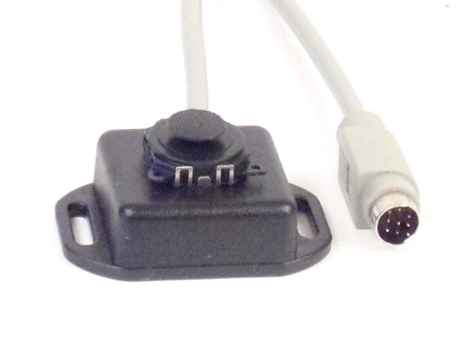

Cost (without shipping): $208.00 CAD

Dimensions: Not given

Features:

* Made to work with [Versatilty v3](https://inclusiveinc.org/products/v3) with circular 8 pin analog joystick port
* Low profile (no dimensions indicated)
* Mounting slots on the side

1. [MINISTIX-SL Warfighters Engaged](https://warfighterengaged.org/shop/ministix-s)

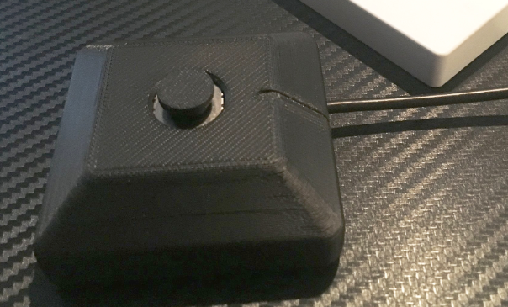

Cost (without shipping): $45.00 USD

Dimensions: Not given

Features:

* ¼-20 threaded hole on the back for mounting.
* 3.5 mm integrated cable

1. [Amazon - PSP type device](https://www.amazon.ca/ZADAI-4-3-inch-Handheld-Console-Portable/dp/B095WXBYSQ/ref=asc_df_B095WXBYSQ/?tag=googleshopc0c-20&linkCode=df0&hvadid=582450275413&hvpos=&hvnetw=g&hvrand=6266306773064355374&hvpone=&hvptwo=&hvqmt=&hvdev=c&hvdvcmdl=&hvlocint=&hvlocphy=9001332&hvtargid=pla-1675176659914&psc=1)

*This example is more of how the device has sliding joysticks incorporated as the PlayStation PSP or Vita are no longer available.

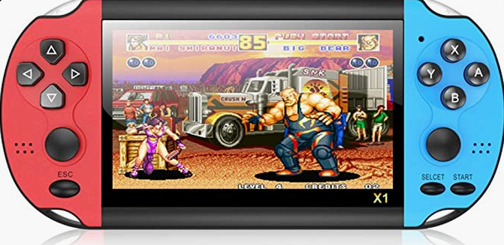

Cost (without shipping): $99.99 CAD

Dimensions: N/A

Features:

* Uses two sliding joysticks in a handheld set up for two handed gaming.
* Replaces the PlayStation PSP and Vita which popularized sliding joysticks in gaming

## Open Source Options:

1. [Slider Joystick MKIII - Ron Nelson](https://www.etsy.com/ca/listing/1191918398/slider-joystick-mkiii-for-xbox-adaptive?click_key=d3bd432ce56c0e6d531869f85e23a9ed4fe7fe8d%3A1191918398&click_sum=caf10b44&ref=shop_home_active_5&crt=1)
   1. Github: <https://github.com/nelsonii/JoystickEnclosures/tree/main/Slider>

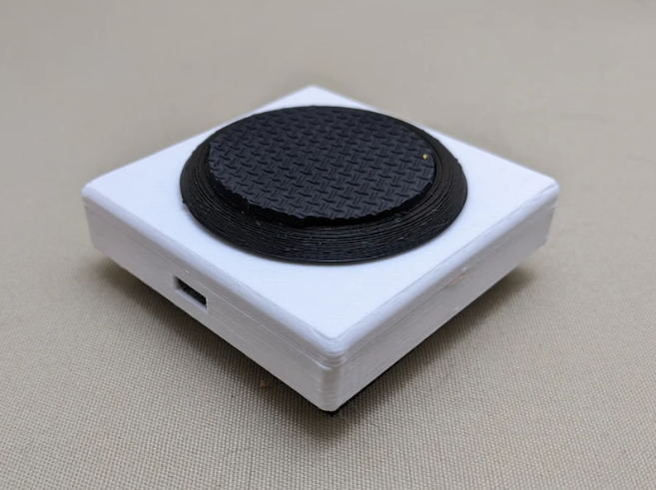

Cost (without shipping):

* Sold for: $77.86 CAD

Dimensions: N/A

Features:

* USB connection (intended for XAC)
* LED indicator light
* PC compatibility and also used with [JoyToKEy](https://joytokey.net/en/)
* Features 3D printed disk topper with rubber 1.5 inch inserts for increased surface area

# Requirements

## Goals

|  |  |
| --- | --- |
| G01 | Minimize the size of the enclosure. |
| G02 | Minimize the cost. |

## Functional Requirements

|  |  |
| --- | --- |
| F01 | The joystick design must have a 3.5 mm TRRS analog output. |
| F02 | The joystick must be compatible with the Xbox Adaptive Controller and Forest Hub. |
| F03 | The joystick shall be designed to be used by either hand. |
| F04 | Joystick must remain stable while in use. |
| F05 | Joystick design must reduce possibilities of damage to electronic components of device by reducing openings to internal components. |

## Constraints

|  |  |
| --- | --- |
| C01 | Joystick must be maker manufacturable. (i.e. made with common tools and materials) |
| C02 | Design must be considered low profile and the total height must not exceed that of the Birch Mini Joystick, which is 24 mm. |
| C03 | The total maker cost must be less than or equal to that of the Birch Mini Joystick-A, which was $38.76. |
| C04 | The joystick must include two M3 nuts 50 mm apart to be compatible with the Joystick Mount Adapters. |

# Ideation

## Key Features

### Joystick Unit

For this design, the same joystick element will be used as the Birch Joystick, the small sliding thumbstick from Adafruit. It is called the “Mini 2-Axis Analog Thumbstick” on the Adafruit website, product number 2765.

### Snap fit to secure joystick

In this design, one of the goals was to minimize the cost, and decrease the cost compared to the Birch Mini Joystick-A design. One of the main costs when doing a single build of this previous design was fasteners, the M2 screws needed to fit through the joystick breakout board were difficult to find in small quantities and had to be bought in a pack of 1000. To eliminate this, a snap fit would be explored to secure the joystick.

### Snap fit enclosure

To further reduce costs, a snap fit enclosure will also be explored, in the aim to eliminate the cost of fasteners altogether.

### Mounting

To allow for different mounting options, captive M3 nuts compatible with the OpenAT Joystick Mount Adapters will be included. These must be 50 mm apart, and will allow different mount adapters to be attached to the bottom of the joystick, including a ¼-20” camera mount.

# Conceptual Design

The size of the joystick unit is quite small, and therefore the required dimensions of the captive nuts for the mount adapter will be the main constraint when it comes to size. There are two main ways the captive nuts can be oriented, vertically, horizontally, or diagonally. To allow users to place other devices close to the joystick, the vertical orientation is preferred over horizontal, so the vertical and diagonal mount adapter options were explored further.

## Concept 1 : Vertical Mount Adapter

With the mount adapter nuts in a vertical orientation, this creates a very long and skinny joystick when trying to minimize size. For aesthetics and stability, more width could be added to this design if needed. The dimensions of this concept would be approximately 35 mm x 60 mm at this minimum size.

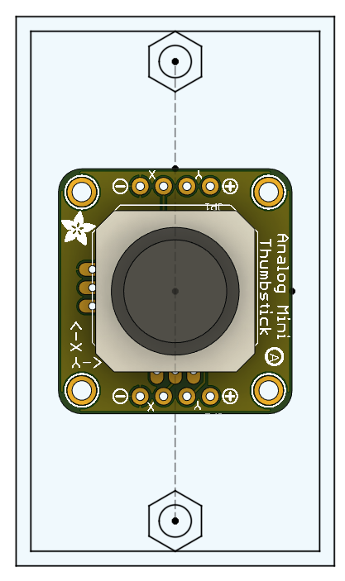

## Concept 2 : Diagonal Mount Adapter

With the mount adapter nuts in a diagonal orientation, the joystick would be more square. At these minimum dimensions, the size of this concept would be around 45 mm x 45 mm.

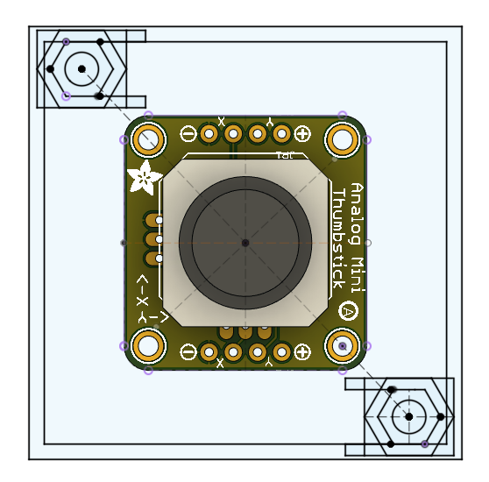

## Concept Selection

The concept with the diagonal mount adapter nuts was chosen, due to its more square geometry, which would be more stable while in use, is more aesthetically pleasing, and has a smaller overall footprint.

# Detailed Design

## Overview

The Aspen Sliding Joystick is small and compact, with a snap fit enclosure. Below the overall design is pictured:

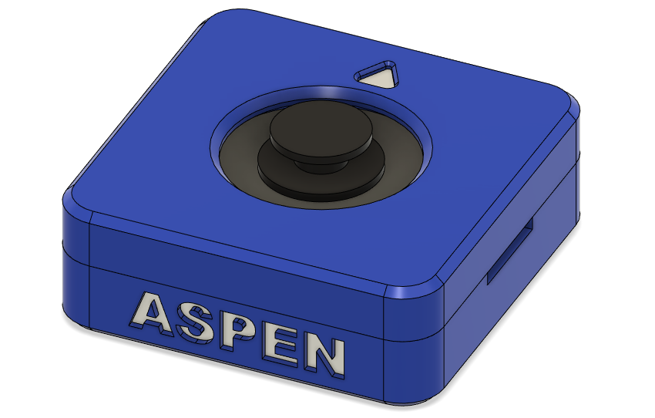

### Components

The components used in this design are the sliding joystick module and breakout board, a TRRS stereo audio cable, and 2 hex nuts. The parts are all listed in the following table, and more information including prices can be found in the Bill Of Materials (BOM).

|  |  |  |
| --- | --- | --- |
| Part Name | QTY | Link |
| Mini 2-Axis Analog Thumbstick | 1 | <https://www.digikey.ca/en/products/detail/adafruit-industries-llc/2765/6193582> |
| Analog Mini Thumbstick Breakout Board | 1 | <https://www.digikey.ca/en/products/detail/adafruit-industries-llc/3246/6193594> |
| 3.5 mm stereo cable (4 conductor, TRRS, M-M) | 1 | <https://www.digikey.ca/en/products/detail/tensility-international-corp/10-00332/2350238> |
| M3 hex nut | 2 | <https://www.digikey.ca/en/products/detail/keystone-electronics/4708/4499301> |

The Aspen Joystick was designed around this thumbstick module listed above and pictured here:

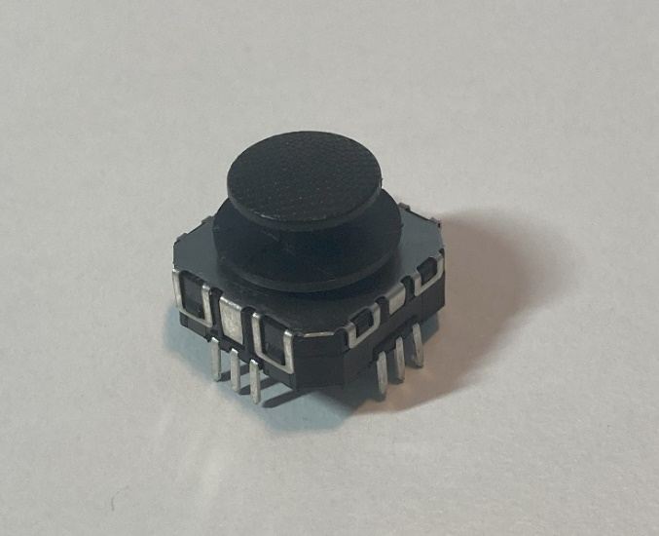

The other key component is the joystick breakout board listen above and pictured here:

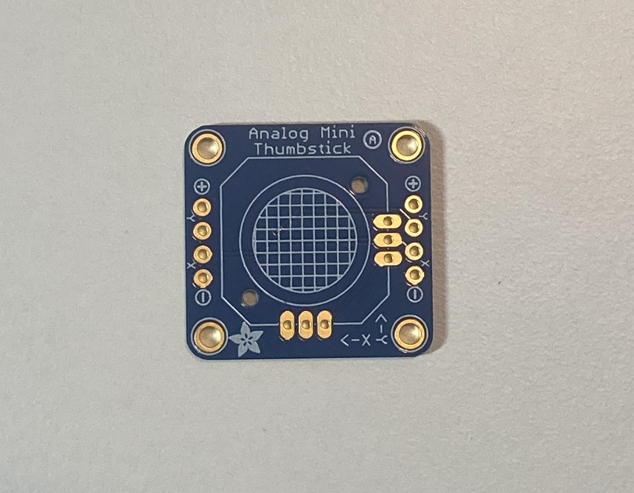

## Electronics Design

### Wiring Diagram

The following photo and table show how the joystick is wired to the TRRS cable.

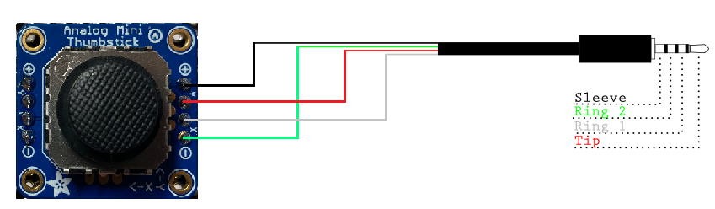

Figure 1. Joystick Wiring Guide. Image Remixed from Sparkfun, released under a CC BY 2.0 license.

Table 1: Aspen Wiring

|  |  |  |
| --- | --- | --- |
| Joystick Breakout Board | CONNECTION | Digikey TRRS Cable |
| + | Sleeve (S) | Black |
| Y | Tip (T) | Red |
| X | Ring 1 (R1) | White |
| - | Ring 2 (R2) | Green |

## Housing Design

### Outer features

On the outside of the enclosure there are a few key features. On the side facing the user, “ASPEN” is engraved, and on the side facing away rom the user “MMC” is engraved. There is also an arrow on the top of the enclosure showing the up direction.



On the sides of the enclosure there is a small indent, to allow for some leverage when prying apart the snap fit enclosure. On the backside of the enclosure there is a hole for the cable exit.

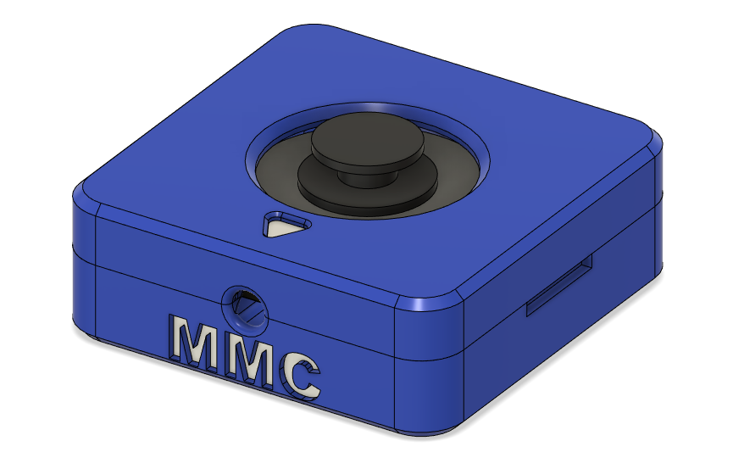

### Housing Footprint

One of the goals with the Aspen Sliding Joystick was to reduce the size compared to the Birch Mini Joystick. Here, the footprint was able to be reduced significantly, only needing room for the joystick breakout board, and enough distance between the captive nuts for the mount adapter. The footprint of the Aspen Sliding Joystick is 45 mm x 45 mm as seen below:

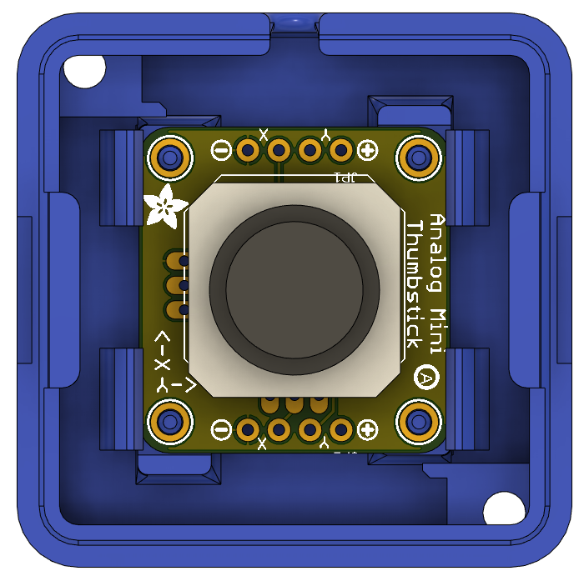

45mm

45mm

This is a significant size reduction compared to the previous design, the Birch Mini Joystick, which had a footprint of 60 mm x 68 mm, shown below.

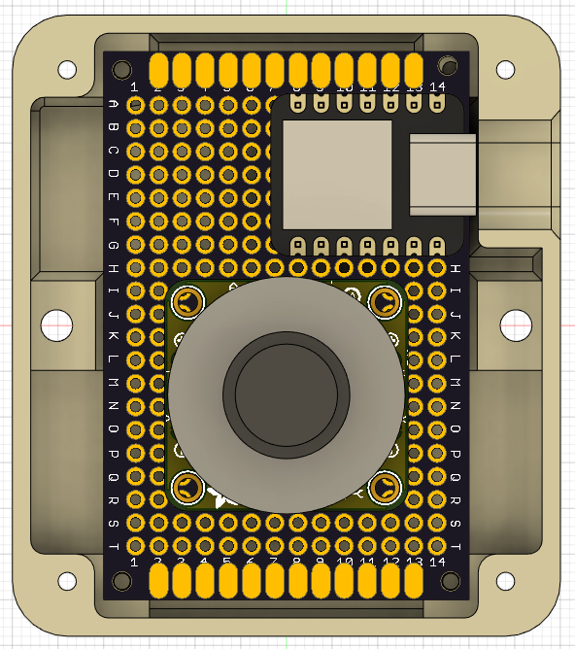

60mm

68mm

Here the two joystick designs are shown side by side to compare:

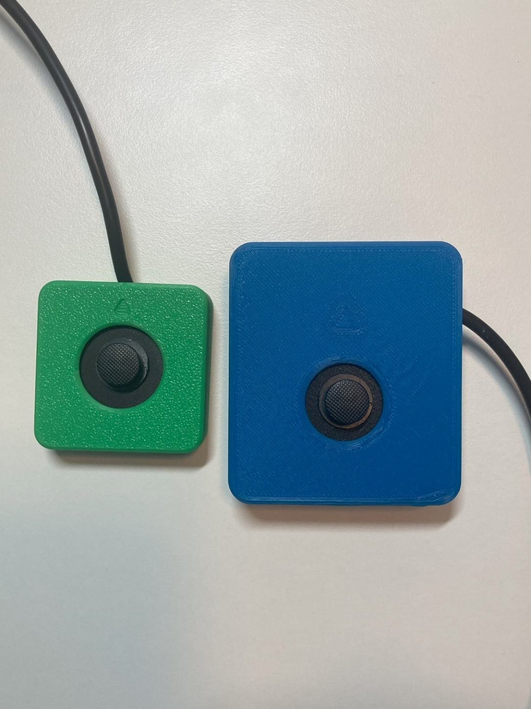

### Housing Height

The overall height of the joystick housing is 15.7 mm. Some key measurements here are the distance below the joystick breakout board, to allow for clearance of the wires after soldering, and the distance between the top of the joystick and the top of the enclosure.

The distance between the bottom of the joystick breakout board and the bottom of the enclosure is 3 mm and can be seen here:

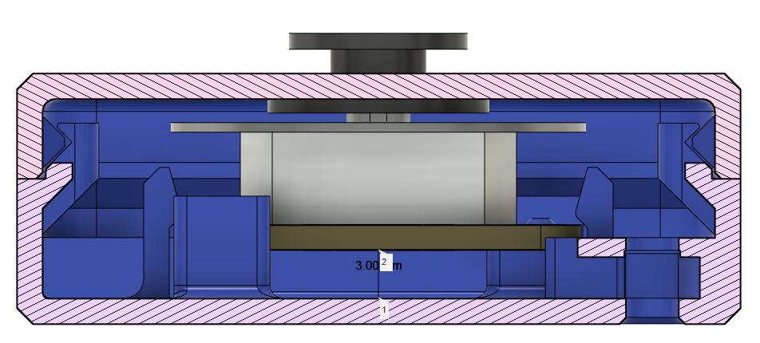

The distance between the top of the joystick unit and the top of the enclosure is 2.1 mm to allow for the 0.6 mm inner disk and space for smooth sliding between all of these parts, while considering the imperfections of 3D printing, and how not all parts will be fully flush in reality.

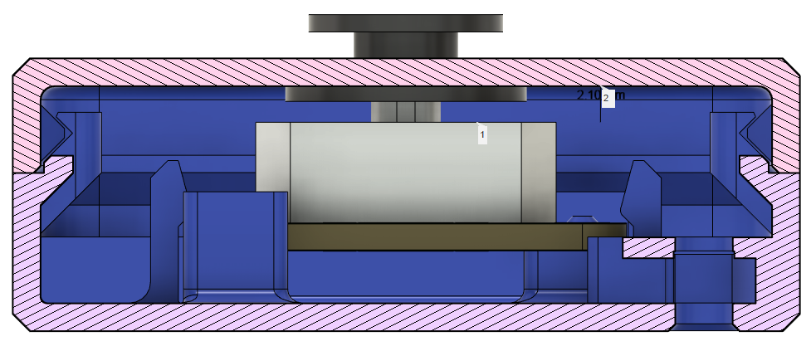

### Mount Adapter Captive Nuts

Like the other OpenAT Joystick designs, the Aspen joystick needed to include captive nuts compatible with the OpenAT Mount Adapters, to allow mounting options when not used on a tabletop. The mount adapters use M3 nuts and screws, with the centres of these nuts are 50.0 mm apart. In this design, the mount adapter will attach diagonally. These two slots are seen in the photos below. As seen in the photo, around the hole above the captive nut, which would be printed unsupported, there are small single layer rectangles, [this is a best practice when 3D printing unsupported holes.](https://www.hydraresearch3d.com/design-rules#unsupported-holes)

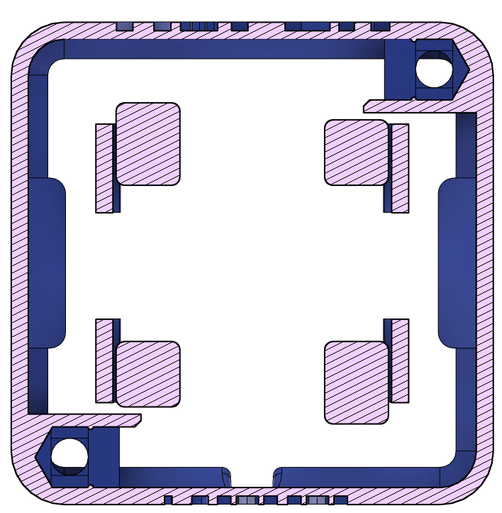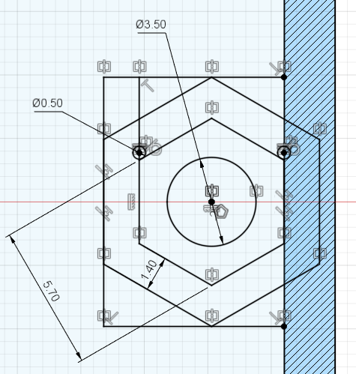

50 mm

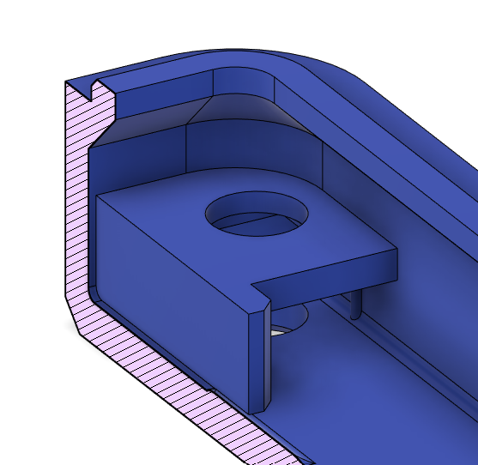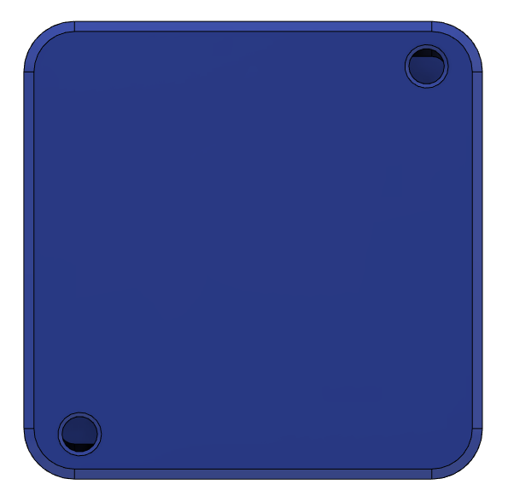

### Joystick Snap Fit

To hold the joystick breakout board in place, a snap fit and 4 pegs were used to secure it to the bottom of the enclosure. The 4 pegs ensure the joystick stays in position front to back and side to side, while the snap fit ensures that the joystick doesn’t move up and down or come out of the enclosure. Both the snap fit and the pegs can be seen in the cut out view below. The geometry of the snapfit is also shown with some of the key measurements.

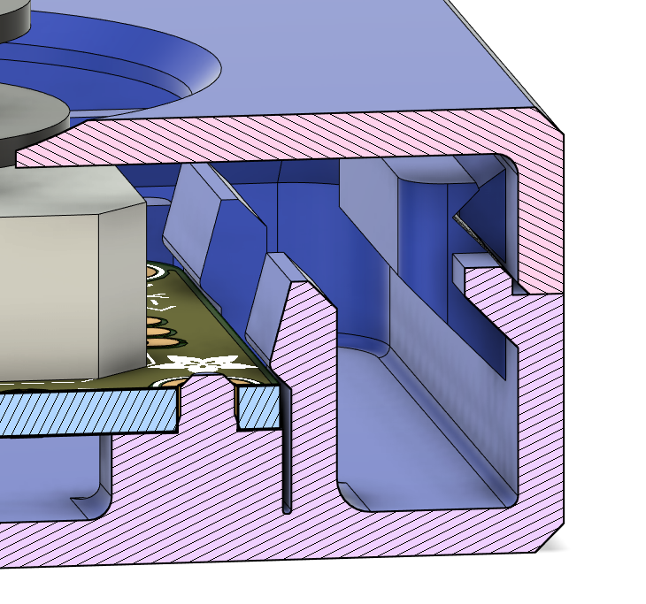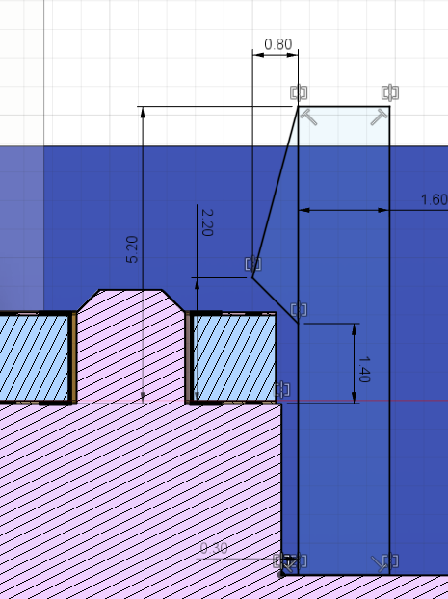

The posts are all 0.965 mm in diameter to allow the joystick to fit on snugly, and the distance between the posts is 20.32 mm x 21.59 mm. This can be seen in the photo below.

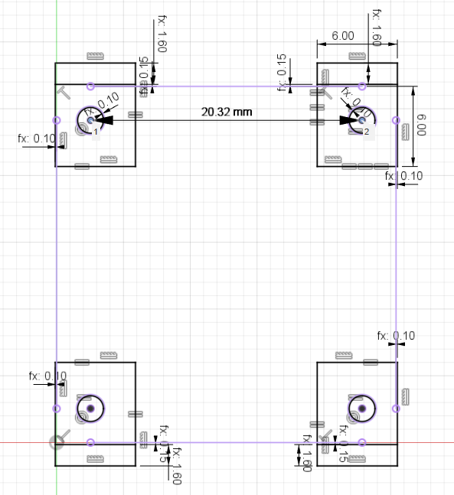

21.59 mm

R=0.965 mm

### Housing Snap Fit

To secure the housing together, a snap fit was used. This was to eliminate the need for screws, and therefore reduce the cost of the device.

On the bottom of the enclosure, a piece sticks up above the top surface and has a triangle indent for the top piece to snap into:

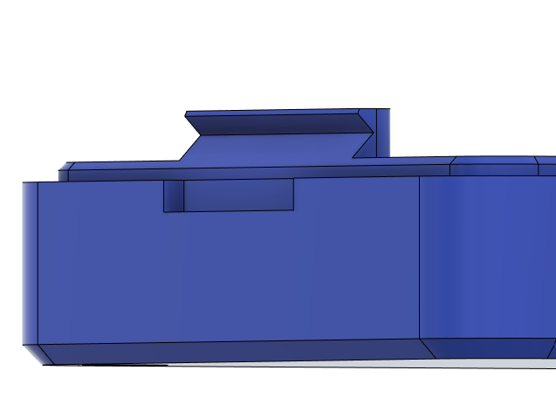

On the top of the enclosure there is a triangular piece that sticks out to fit into the bottom the the enclosure, along with some fillets and drafts:

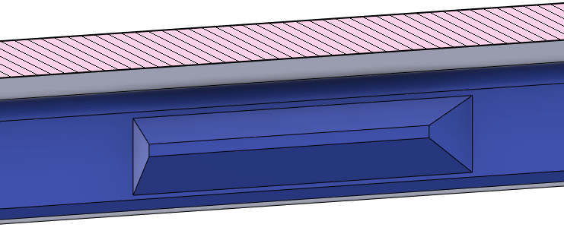

In the following section view it can be seen how the pieces fit together as well as some of the geometries and measurements:

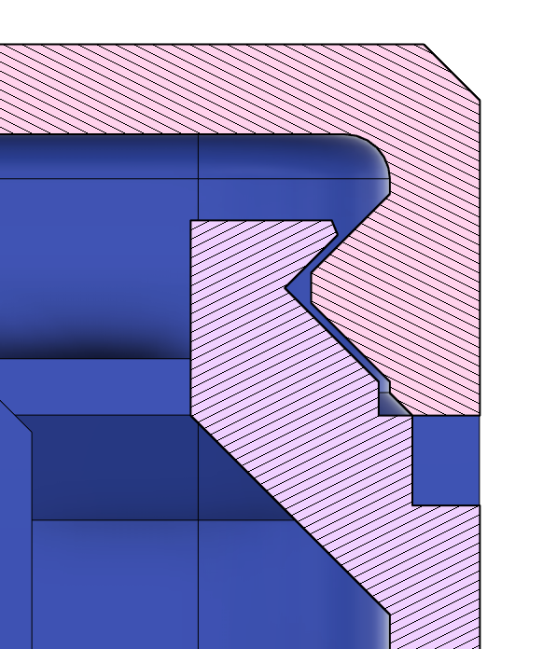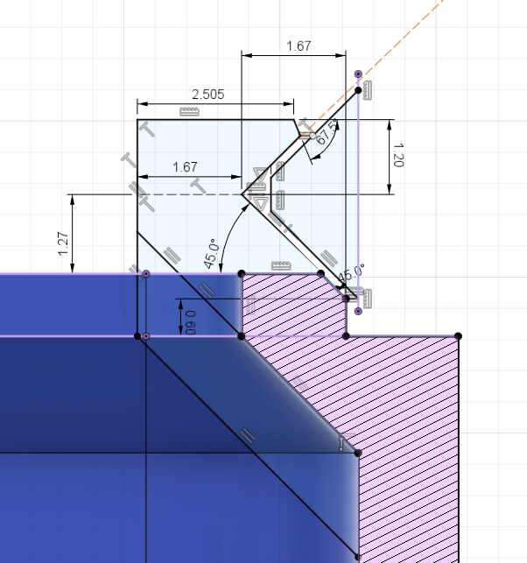

### Inner Disk

To protect the inner electronics of the joystick, a small disk was added between the sliding joystick component and the topper. The photos below show how the disk is added to the joystick by removing the topper. The disk is 0.6 mm thick so it is thin but still has structural integrity by being three print layers thick. This disk does not need to be strong as there will be no bending force applied to it. It is important to look at the quality of this print, and if there are any bumps or zits, to either cut these off with a craft knife or use sandpaper to create a smooth surface and prevent binding.

|  |
| --- |
| Joystick breakout board without joystick topper Joystick with inner disk placed on joystick post. Joystick with inner disk and joystick topper. |

### Cable Routing

In this joystick design, the TRRS cable is routed around the outside edge inside the enclosure. Since the cable is relatively snug going around the corners, this also provides enough tension relief that if you pull on the cable it won’t pull on the soldered connections.

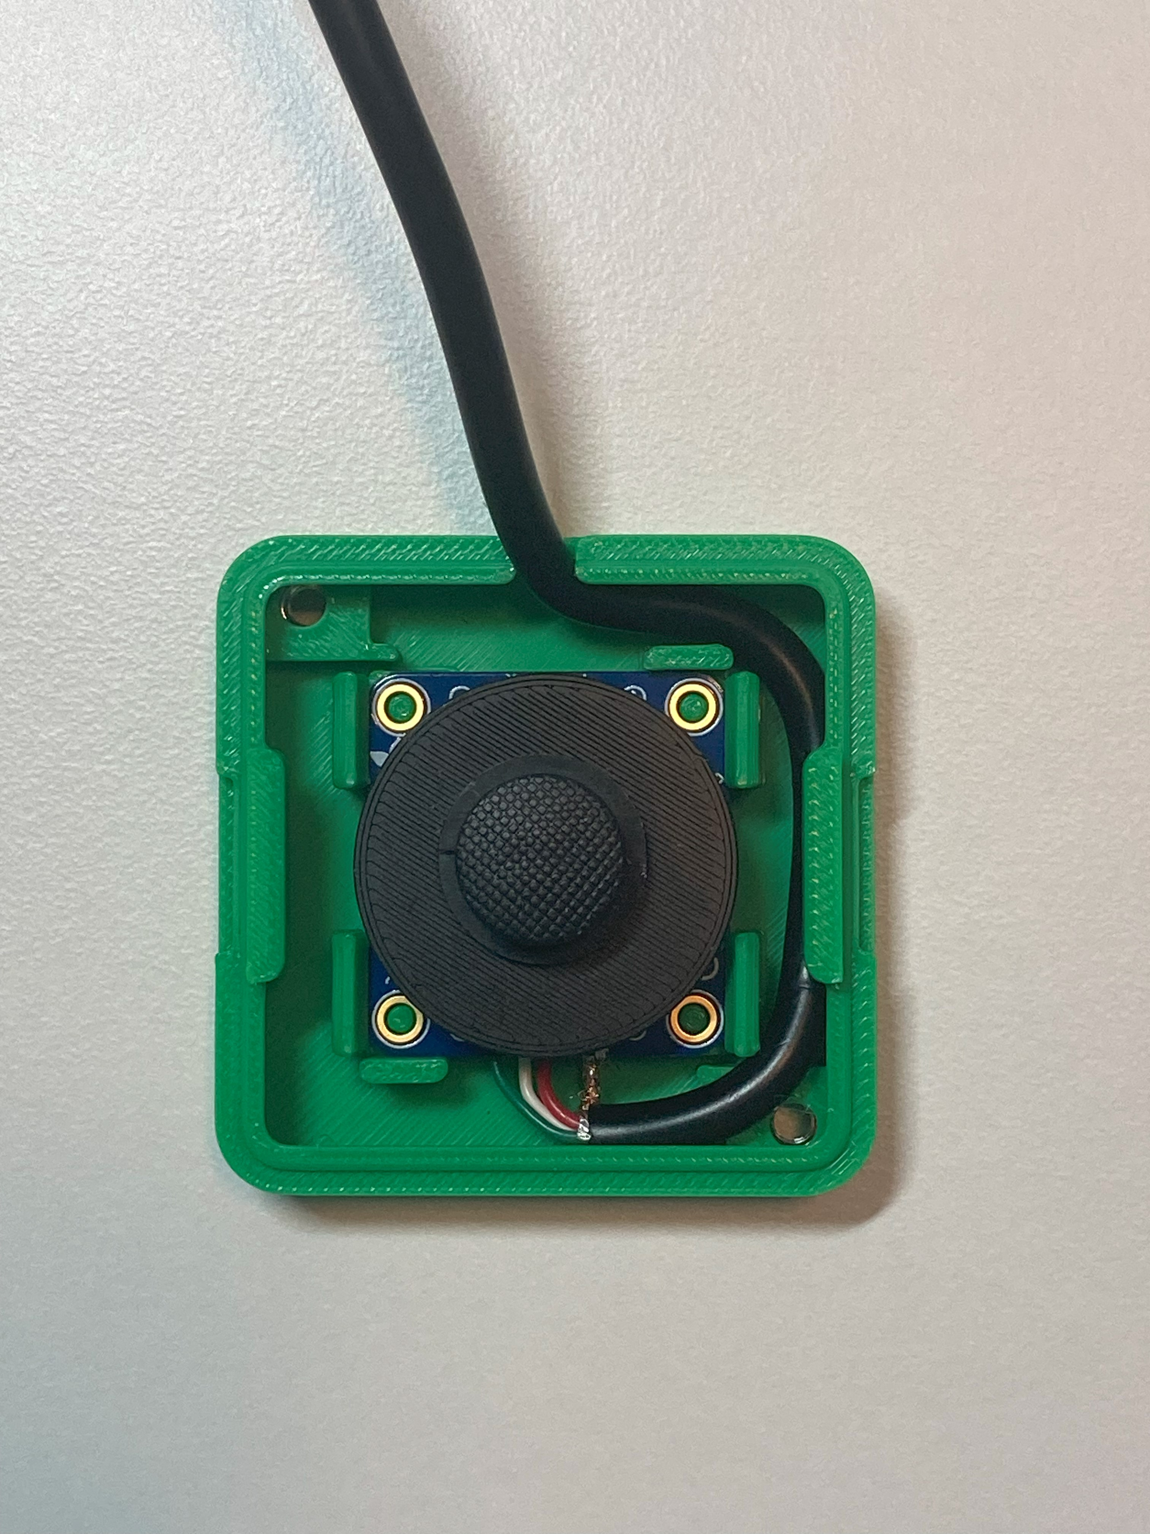

## Assembled Prototype

Below are some photos of the assembled prototype:

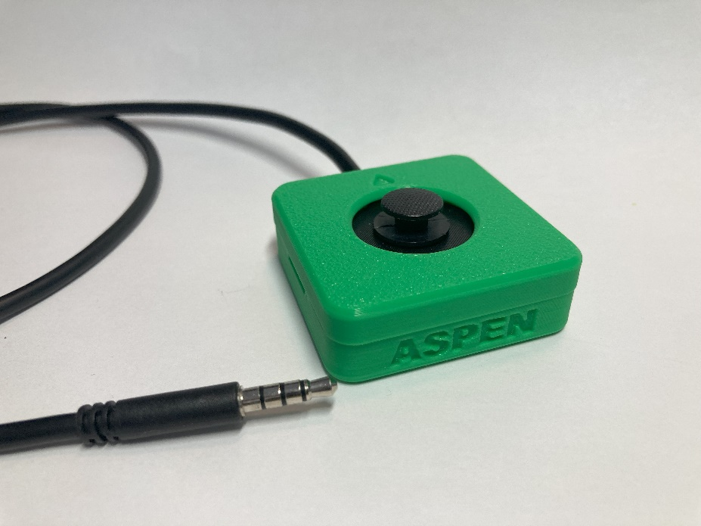

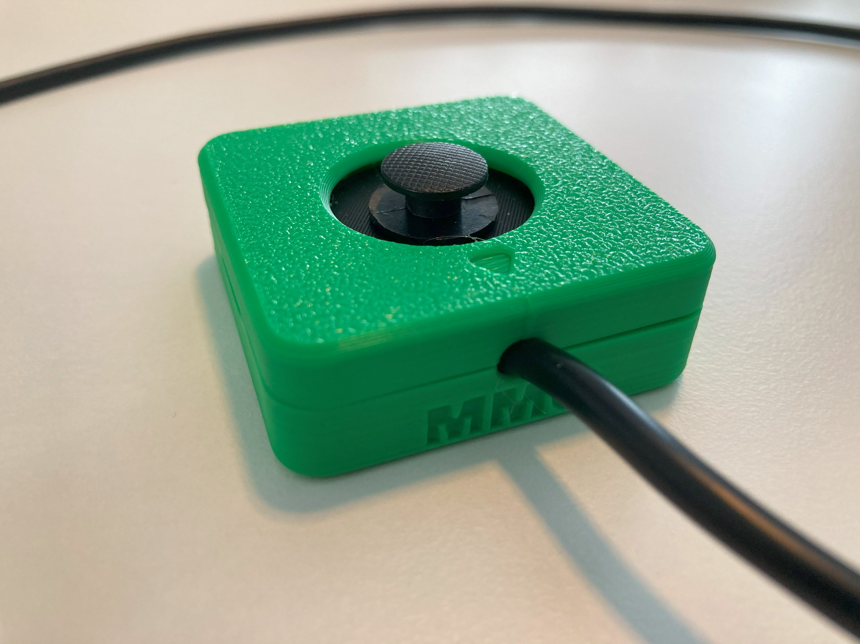

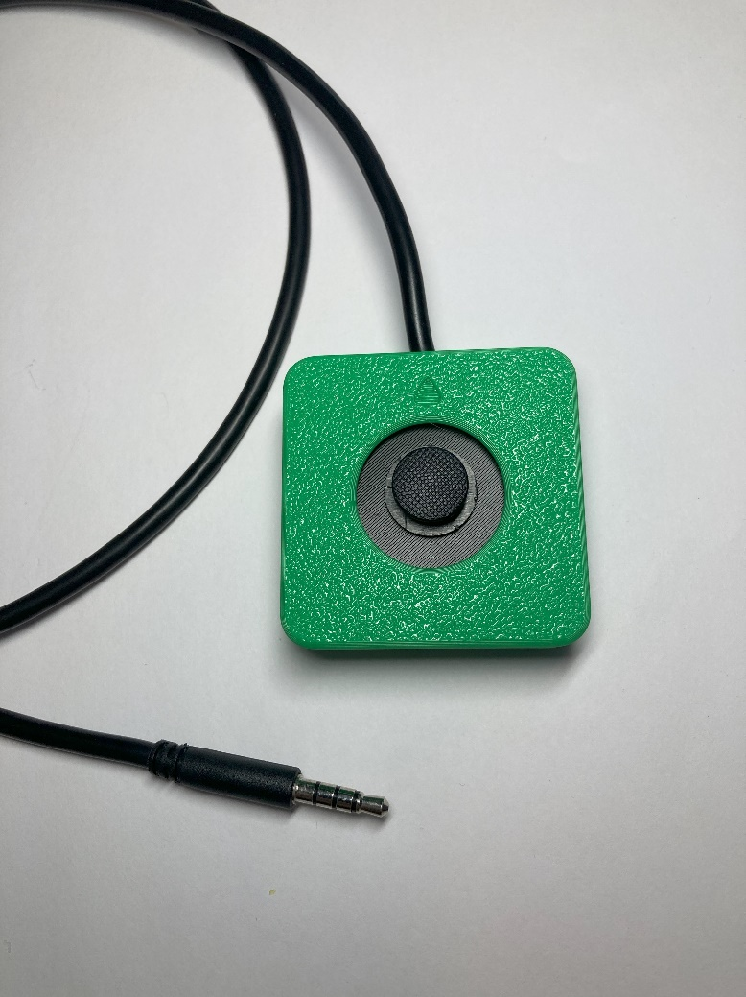 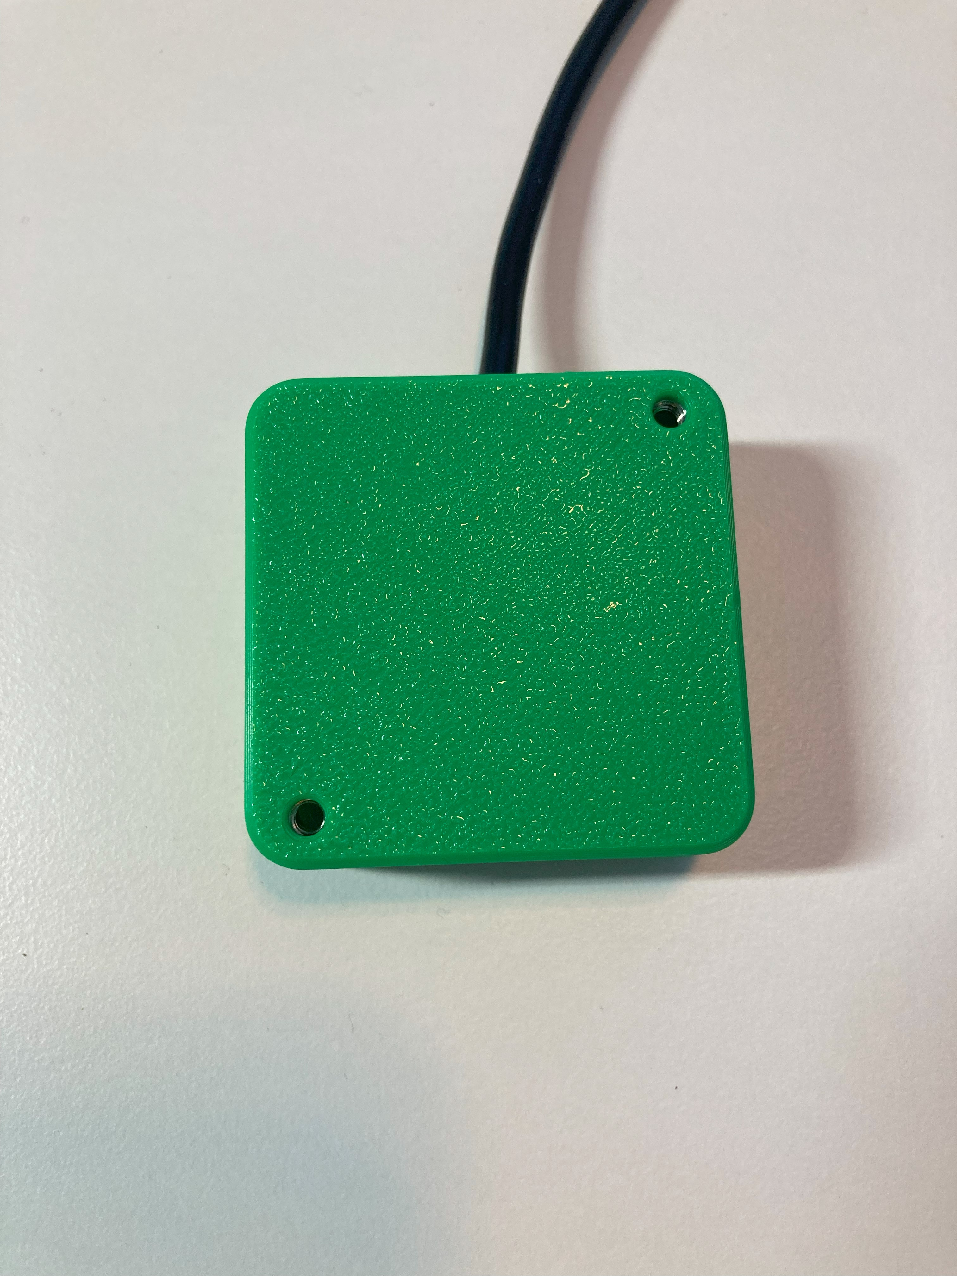

Assembled prototype with camera mount adapters and RAM mount adapters attached:

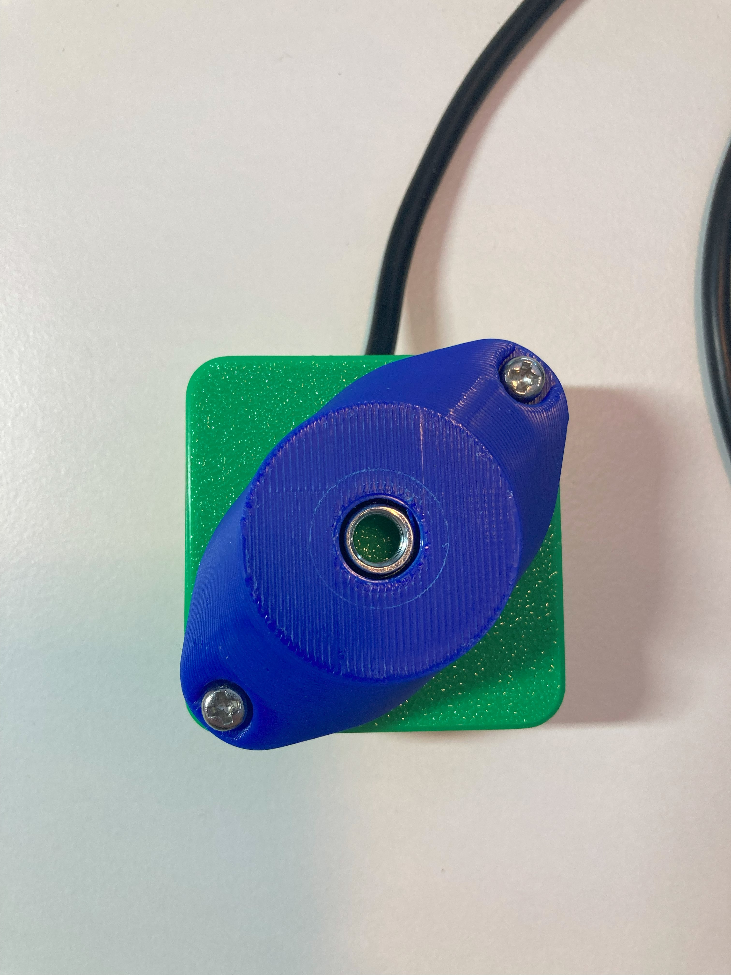 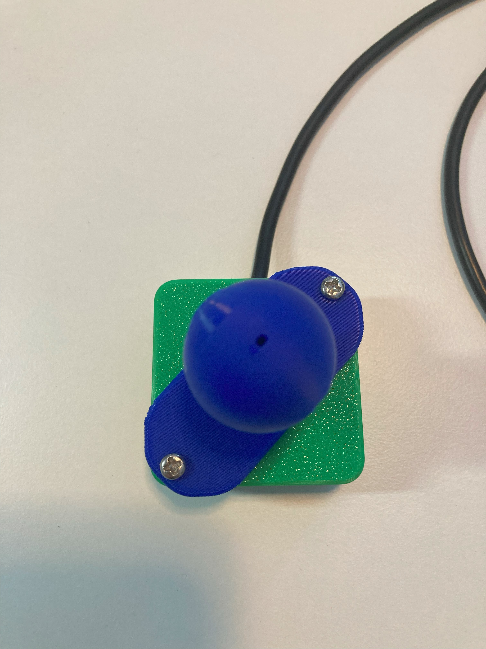

# Final Design

## Opportunities for Improvement / Future Work

* Could add a feature to the outside of the enclosure to allow for snap on piece for wrist supports and other bases